**Homework 1**

1. In the 8-queens problem, if we don’t use any restriction before building the phenotype space, the total phenotype space is $64×63×62×61×60×59×58×57$. (Because each queen can put in anywhere of the 8*8 chess board and so on)

However, according to the rule of chess, we can use some restrictions to simplify the space of the phenotype in order to reduce computation of optimization algorithm.

*Restriction1: each row contains only one queen*

*Restriction2: each column contains only one queen*

Based on above restrictions, we can put one queen each time at unique row. First queen has 8 options to choose for the first row and second queen has only 7 options for the second row because the column occupied by first queen cannot be put. Follow this procedure, we can get the phenotype space is $8×7×6×5×4×3×2×1=8!=40320$

1. Assume here we use most straightforward method to represent genotype of floating number (fractional binary representation, not IEEE standard):

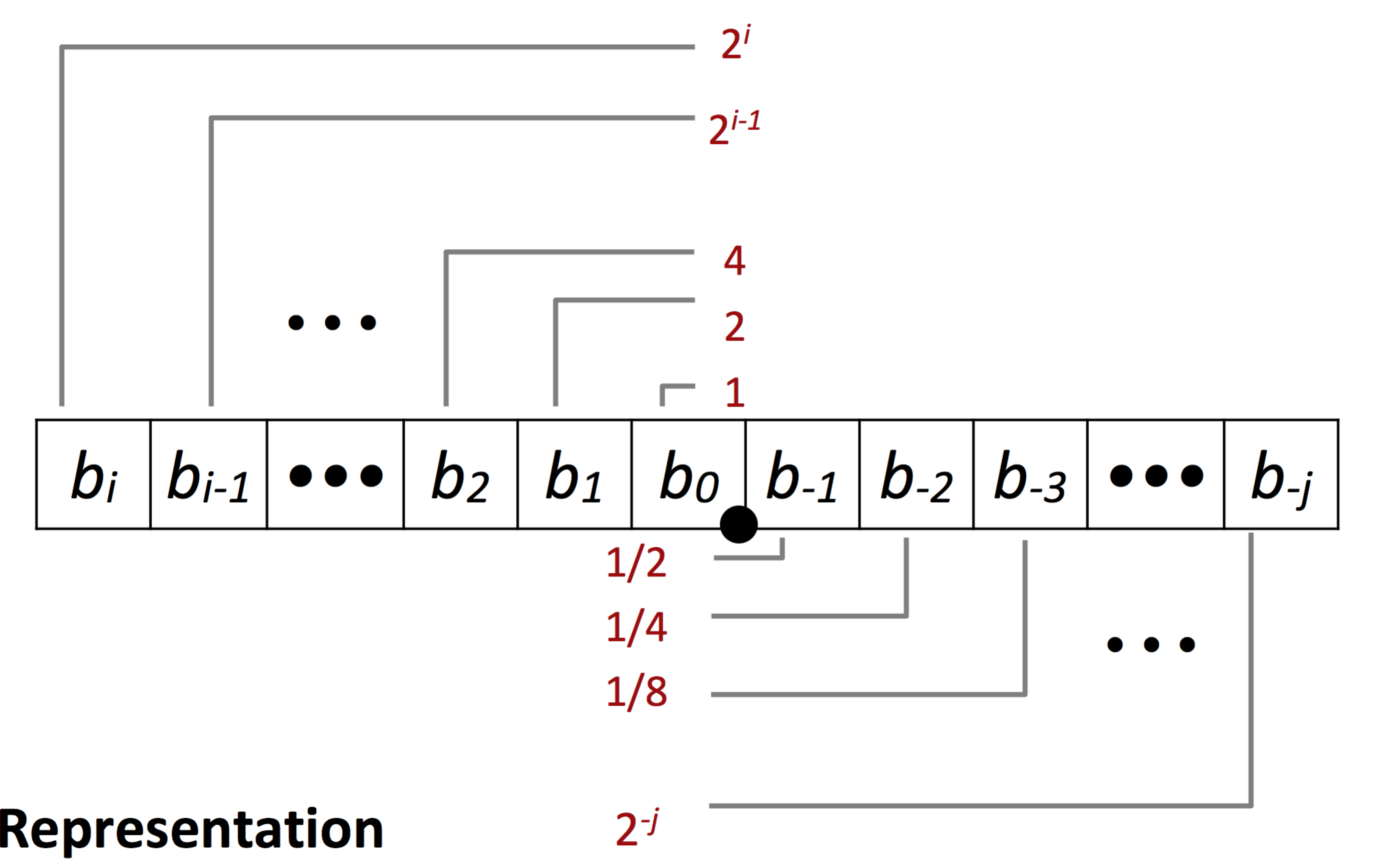

Therefore, if we want to achieve precision of 0.001, the fractional bit at least should be down to $1/{1024}=0.000976$. That is to say, we at least need $b_{-1}b_{-2}b_{-3}b_{-4}…..b_{-10}$ these 10 bits to represent genotype to achieve required precision.

1. Binary chromosome with length L means it is a bit-string with L bits. Each bit has the mutation probability $p_{m}=1/L$. Therefore, the unchanged rate of this chromosome is ${(1-1/L)}^{L}$
2. According to the question, it uses fitness proportionate selection method. Therefore, we can use the following formula:

${Prob}_{i}=\frac{f_{i}}{\sum{f_{j}}}$ where $f_{i}$ means fitness value for individual i and the expected number of copies of each individual after selection is ${f_{i}}/{\overline{f}}$.

* Therefore the question 1 is to calculate the expectation of best individual present in the mating pool, we can fill the numbers mentioned in the question:

Expectation = ${f_{i}}/{\overline{f}}=\frac{157}{76}≅2.066$

* Calculate the probability of others’ copy present in the mating pool except for the best one.
$$p\left(not best\right)={( 1-{Prob}_{best})}^{100}={(1-\frac{157}{100×76})}^{100}≅{0.9793}^{100}≅0.1235$$

* As compared with above question using roulette wheel algorithm, this problem uses fitness proportionate selection combined with different method, SUS. However, the probability of the final result is the same. SUS method is to make expectation number round to integer that is better for practical use. It will not affect the value of probability based on the formula.

1. Given that the frequency of allele being 1 at position i is 0.3 (i.e 30%). Conversely, it has 70% possibility to be 0 at position i. After k one-point crossover operations, this frequency will not change. Because this problem is still in the same population pool, and crossover operations will change its genotype but not its frequency.

Also, I use different crossover method such as uniform crossover, and the frequency is still unchanged.

6.

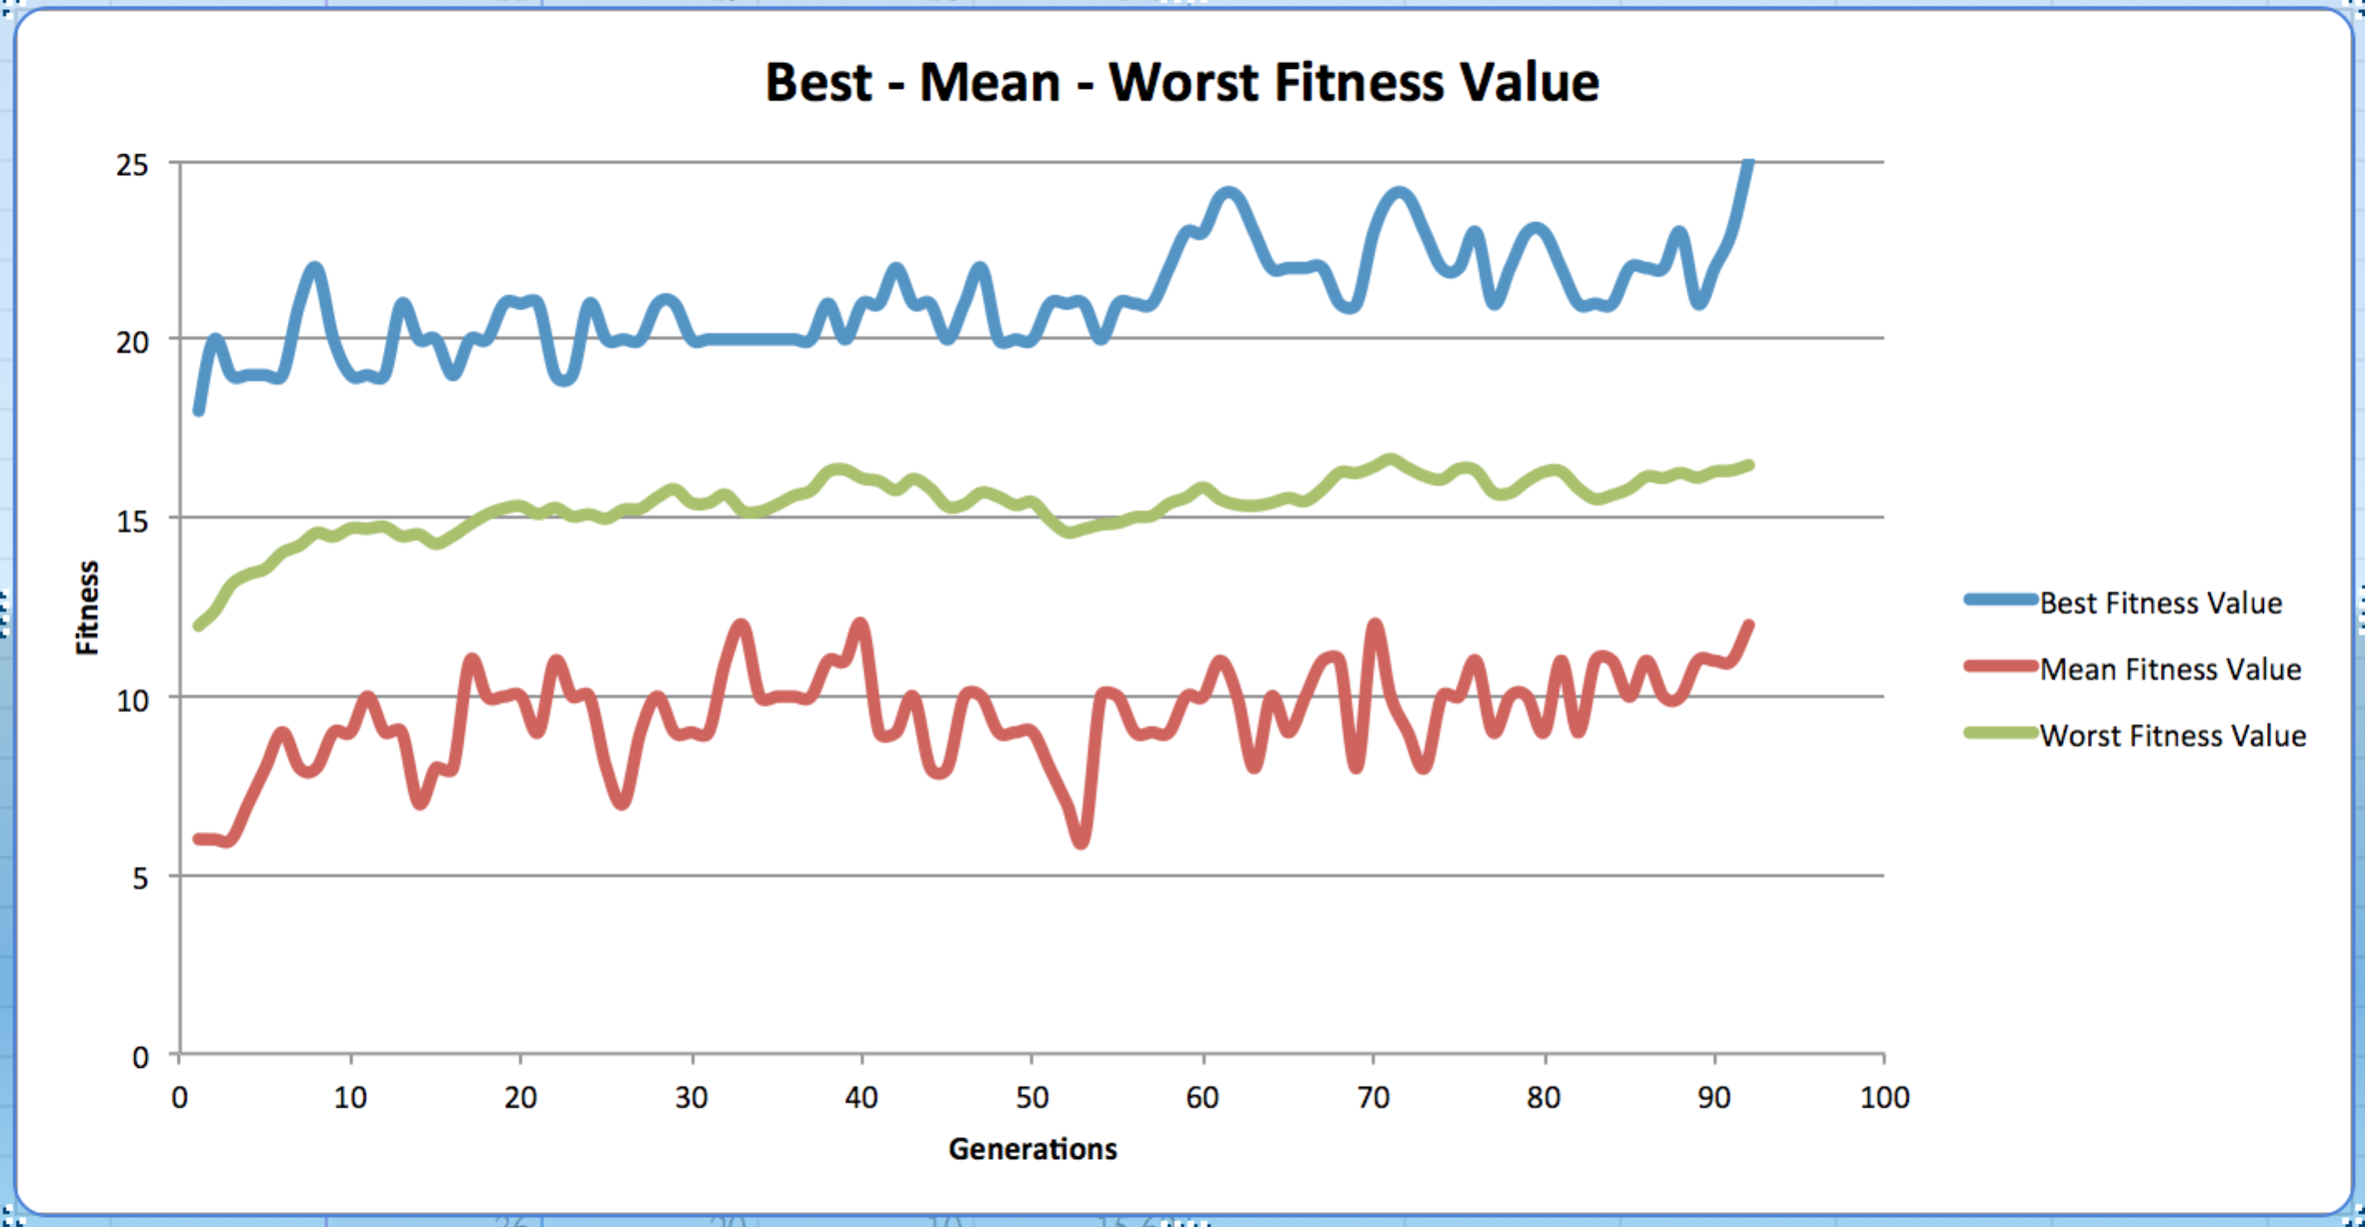

With seed(1234), the result of first run is above plot. When program reaches 92th generations, it will find the optimal value (25). Next, I do ten runs for this program to calculate computation time for finding optimal value. The following table means it takes such time (second) per run to find optimal value.

|  |
| --- |
| 0.184696913 |
| 6.285181046 |
| 0.127841949 |
| 0.696300983 |
| 2.46056819 |
| 0.763385057 |
| 15.59874892 |
| 1.894160986 |
| 0.446084023 |
| 1.318645 |

Mean = 2.9776 sec Std = 4.7943